Kadijatu Bah

10/27/2018

Lab 6

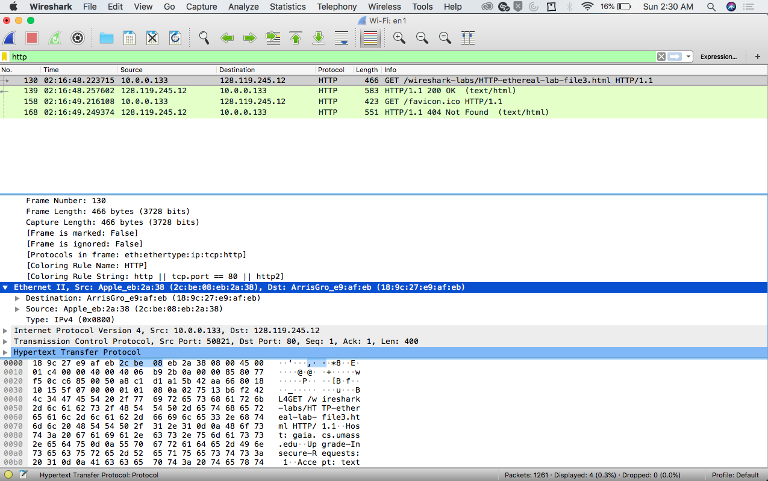

* Questions:
  1. What is the MAC address from your computer?
* **The MAC address for my computer is 2c:be:08:eb:2a:38.**



* 1. What is the destination MAC address?
* **The MAC address for the destination is 18:9c:27:e9:af:eb.**



* 1. What device has the MAC address shown in the destination?
* **The device is ArrisGro_e9:af:eb.**

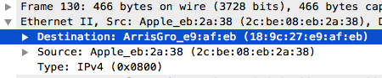

* 1. Explain the relationship between the destination MAC address and the destination IP

Address.

* **The address resolution protocol (arp) is used by the Internet Protocol to map IP addresses to MAC addresses. When the source sends something to the destination, the source’s ARP table sends information to the destination using IP only because the source machine doesn’t have the destination MAC address, so the source machine uses the destination IP address in order to get the destination MAC address.** 
  1. Using the terminal (cmd in Windows, Terminal in mac), run a command to display your

full ARP list table. (Find out what the command is, and print a full screen shot of your result.)

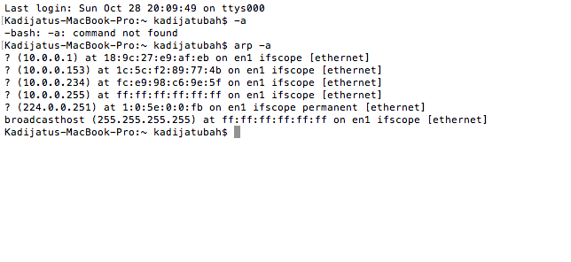

---------------------------------------------------------------------------------------------------------------------------

Ip address

